**IS312 Web Design – TypeScript/JavaScript**

**HOP02 Arrays and Objects**

8/29/2019 Developed by Kevin Kuanting Chen

10/03/2020 Revised Kim Nguyen

Center for Information Assurance (CIAE) @City University of Seattle (CityU)

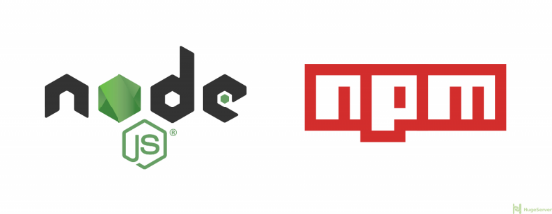  

**Before You Start**

* The directory path shown in screenshots may be different from yours.
* Some steps are not explained in the tutorial**.** If you are not sure what to do:
  1. Consult the resources listed below.
  2. If you cannot solve the problem after a few tries, ask a TA for help.

**Learning Outcomes**

Students will be able to:

* Understand arrays, tuples, and objects in TypeScript

**Resources**

* [W3School Data Types](https://www.w3schools.com/js/js_datatypes.asp)

**Preparation**

1. Open the VS Code and open the repository you cloned from Github, if you have not cloned, go back to the Github repository generated when you accept the HOP assignment, read the instruction on how to clone the repository, before proceeding.

1. Open the terminal from the VSCode by hitting the control + ~ key, check your current directory using the following command, if you are in **Module 2**, you are in the right place:

>>> pwd

**Arrays**

1. Create a **arrays.ts** file under this module’s folder and type the following code in the file.

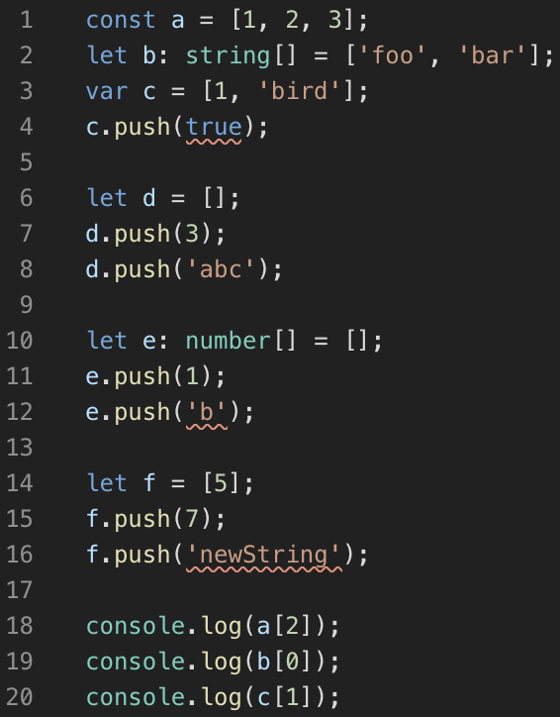

1. Compile your TypeScript. **You will get three error messages.** Read the error messages and understand why you got them.

>>> tsc arrays.ts

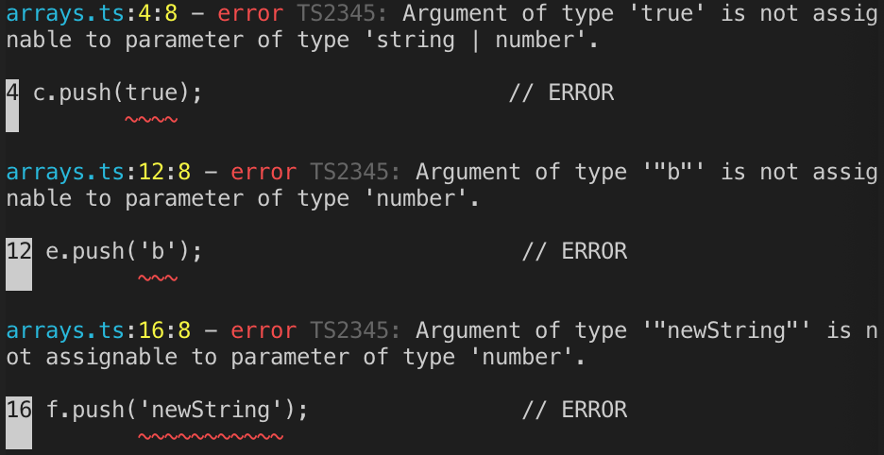

1. Comment out the three lines of code that caused the problem, compile your TypeScript code, and run the JavaScript file.

>>> tsc arrays.ts

>>> node arrays.js

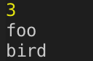

1. Add the following code into your **arrays.ts** file.

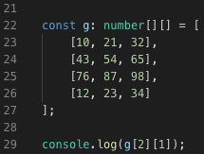

1. Compile your TypeScript code and run the JavaScript file.

>>> tsc arrays.ts & node arrays.js

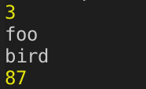

**Tuples**

Tuples and arrays have the same syntax in JavaScript, but they have different syntax in TypeScript. Why? JavaScript lacks the syntactic support for tuples. Tuples are a special way to type arrays with fixed lengths. We explicitly declare specific types and values of each index of a tuple.

1. Create a **tuples.ts** file under this module’s folder and type the following code in the file.

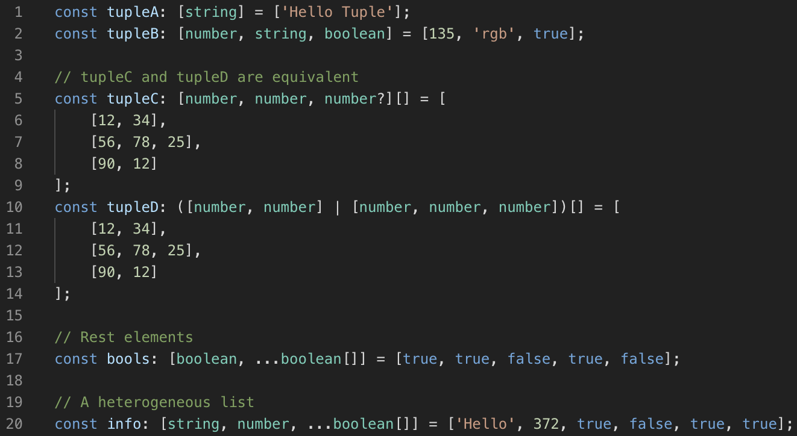

Compile your TypeScript code. Take a look at your tuples.js file. Compare the code with arrays.js. You will see that the syntax is the same.

**Objects**

Objects are instances (a particular variable with that object as its value type) of classes. Classes as just a group methods and variables.

1. Create an **objects.ts** file under this module’s folder and type the following code in the file.

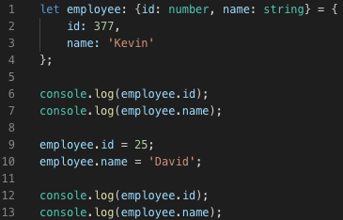

1. Compile your TypeScript code and run the JavaScript file.

>>> tsc objects.ts

>>> node objects.js

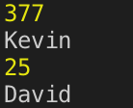

1. Add the keyword readonly to the first line.

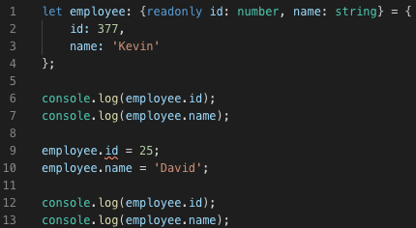

1. Try compiling it. **You will get an error message.**

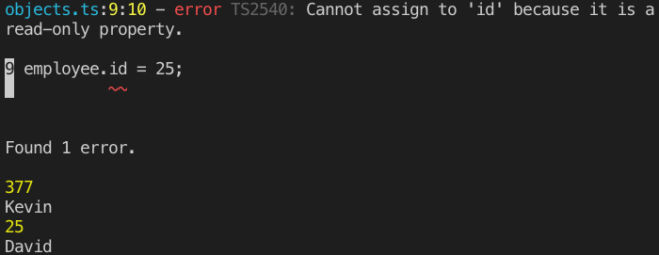

**Explanations**

In line 3, we let the array be (string | number)[] data type, so it can only store strings and numbers.

In line 10 and line 14, we let the arrays be number[] data type, so they can only store numbers.

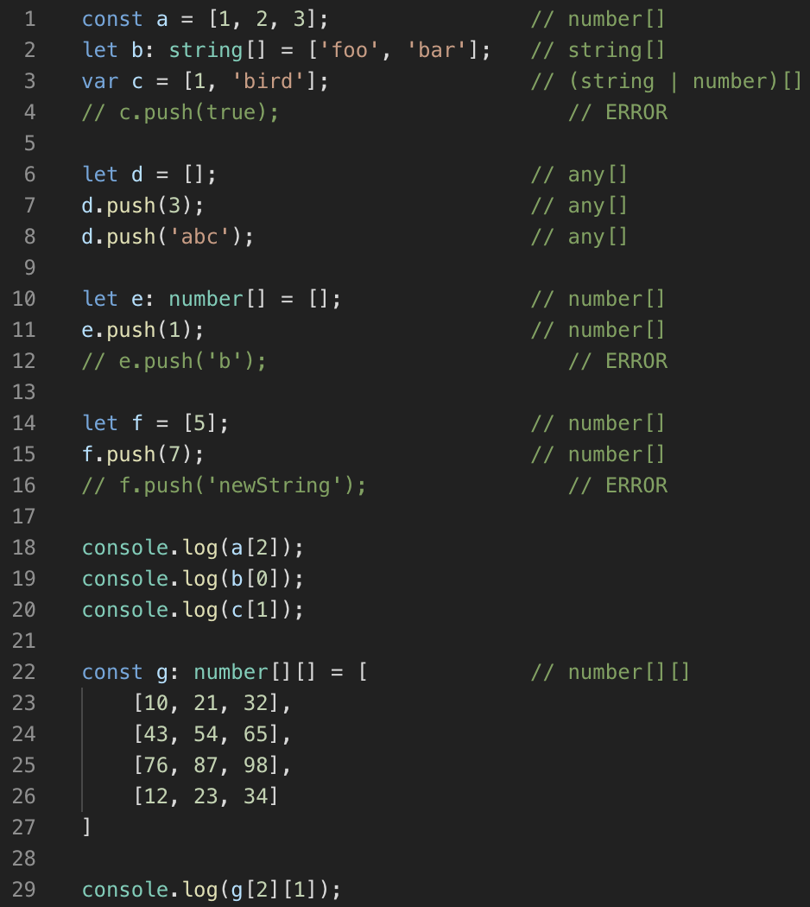

**Push your work to GitHub**

Run the following commands to push your work to the GitHub repository:

Open the terminal from the VSCode by hitting the control + ~ key and type the following command:

>>> git add .

>>> git commit -m “Submission for Module 1”

>>> git push origin master